TRƯỜNG ĐẠI HỌC CÔNG NGHỆ THÔNG TIN

KHOA KHOA HỌC MÁY TÍNH

Báo cáo giữa kỳ

**Chủ đề: Quản lý giải vô địch bóng đá quốc gia**  
**Mã lớp:** SE104.N24.CLC  
**Giảng viên hướng dẫn:** Ths. Nguyễn Thị Thanh Trúc  
**Nhóm thực hiện:** Nhóm 13

|  |  |
| --- | --- |
| **Họ và tên** | **MSSV** |
| **Đỗ Minh Khôi** | **21521007** |
| **Trần Xuân Thành** | **21520456** |
| **Nguyễn Hà Anh Vũ** | **21520531** |

**Contents**

1. Introduction 2

1.1. Purpose 2

1.2. Document Conventions 2

1.3. Project Scope 2

1.4. References 2

2. Overall Description 3

2.1. Product Perspective 3

2.2. User Classes and Characteristics 4

2.3. Operating Environment 4

2.4. Design and Implementation Constraints 4

2.5. Assumptions and Dependencies (*) 4

3. System Features 5

3.1. Create User Account 5

3.1.1. Description 5

3.1.2. Functional Requirements 5

3.2. Sign-in 5

3.2.1. Description 5

3.2.2. Functional Requirements 5

3.3. Create Team Profile 5

3.3.1. Description 5

3.3.2. Functional Requirements 5

3.4. Schedule Match 5

3.4.1. Description 5

3.4.2. Functional Requirements 5

3.5. Record Match Result 5

3.5.1. Description 5

3.5.2. Functional Requirements 5

3.6. Player Lookup 5

3.6.1. Description 5

3.6.2. Functional Requirements 5

3.7. Create Tournament Report 5

3.7.1. Description 5

3.7.2. Functional Requirements 5

3.8. Change or Add Regulations 5

3.8.1. Description 5

3.8.2. Functional Requirements 5

4. Data Requirements 6

4.1. Logical Data Model 6

4.2. Data Dictionary 6

4.3. Reports 6

4.4. Data Integrity, Retention, and Disposal 6

5. External Interface Requirements 7

5.1. User Interfaces 7

5.2. Software Interfaces 7

5.3. Hardware Interfaces 7

5.4. Communications Interfaces 7

6. Quality Attributes 8

6.1. Usability Requirements 8

6.2. Performance Requirements 8

6.3. Reliability Requirements 8

6.4. Security Requirements 8

6.5. Availabilty Requirements 8

6.6. Inverse Requirements 8

**1. Introduction**

## 1.1. Purpose

This SRS describes the software functional and non-functional requirements for release 1.0 of the National Football League Management (NFLM). This document is intended to be used by the members of the project team who will implement and verify the correct functioning of the system. Unless otherwise stated, all requirements specified here are high priority and committed for release 1.0.

## 1.2. Document Conventions

No special typographical conventions are used in this SRS.

## 1.3. Project Scope

The National Football League Management consists of the following major functions:

* Support manager to create a team profile
* Scheduling matches for the tournament
* Recording match result
* Support user to lookup for player
* Support manager to create a tournament report
* Manager can add or edit regulations

## 1.4. References

* SRS template by Jacksonville State University
* SMS-SRS by team from previous course

# **2. Overall Description**

The product described in this document is a software for national football league management.

## 2.1. Product Perspective

Figure 1. NFLM Use-Case Diagram

The National Football League Management system is a system that support manager to manage the tournament more effectively. The context diagram in figure 1 illustrates the external entities and system interfaces for release 1.0. The system is expected to evolve over several releases.

## 2.2. User Classes and Characteristics

|  |  |
| --- | --- |
| Manager | The Manager is a tournament employee who assist team to create there profile and making report everytime the tournament is over, record match result,… |
| User | User can view all the tournament information like match result, match schedule, team profile and player profile,… |

## 2.3. Operating Environment

|  |  |
| --- | --- |
| OE-1: | The NFLM shall operate correctly with any operating system from Windows, MacOS, Linux that supported Python |
| OE-2: | The NFLM shall permit user access from the cooperate Intranet, from a VPN Internet connection |

## 2.4. Design and Implementation Constraints

|  |  |
| --- | --- |
| CO-1: | The system’s design, code, and maintenance documentation shall conform to the NFLM SDD |
| CO-2: | The system shall use the Microsoft SQL database management system, Python 3.10 |

## 2.5. Assumptions and Dependencies (*)

# **3. System Features**

## 3.1. Create User Account

### 3.1.1. Description

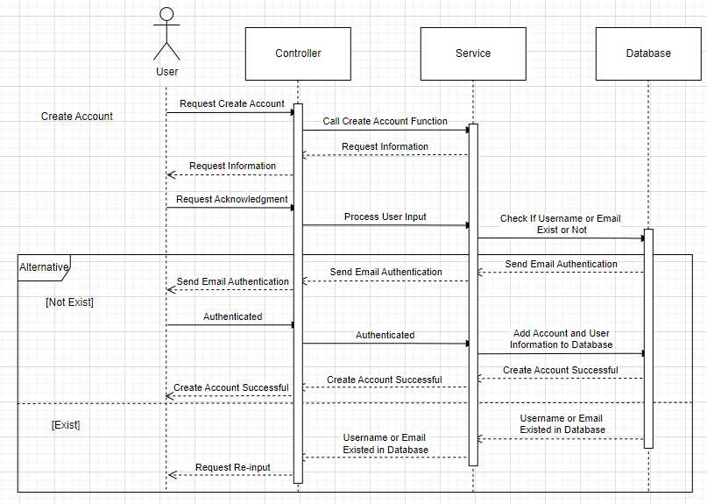

Figure . Create Account Sequence Diagram

### 3.1.2. Functional Requirements

## 3.2. Sign-in

### 3.2.1. Description

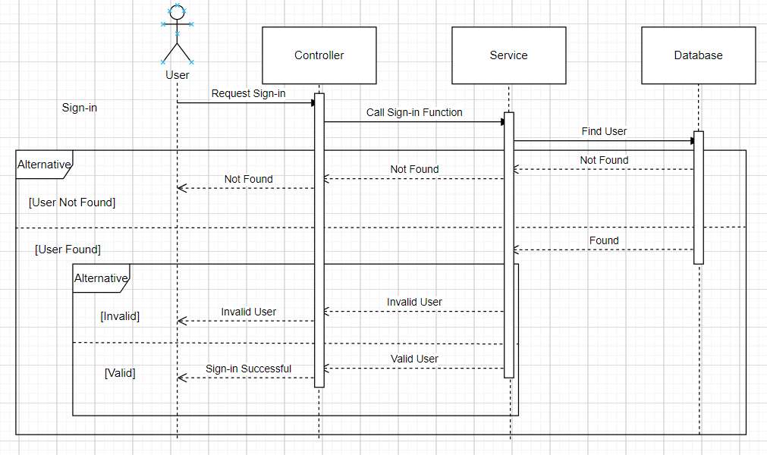

Figure 3. Log-in Sequence Diagram

Any User who has an account can have access to the NFLM system. If the User is a Casual User, he can view information about league, team, match schedule and player. If the User is an Manager, he can make reports and manage related data. **Priority = High.**

### 3.2.2. Functional Requirements

*Request for logging in*

*Introduction*

•The NFLM asks for User’s username and password and asks for its verification via the Database.

*Inputs*

•User’s username

•User’s password

*Processing*

•The NFLM checks for the combination from the data in the Database.

## 3.3. Create Team Profile

### 3.3.1. Description

Figure . Create Team Profile Sequence Diagram

### 3.3.2. Functional Requirements

*Request for create team profile*

*Introduction*

•The NFLM asks for User’s username and password and asks for its verification via the Database.

*Inputs*

•User’s username

•User’s password

*Processing*

•The NFLM checks for the combination from the data in the Database.

## 3.4. Scheduling Match

### 3.4.1. Description

Figure . Scheduling Match Sequence Diagram

### 3.4.2. Functional Requirements

## 3.5. Record Match Result

### 3.5.1. Description

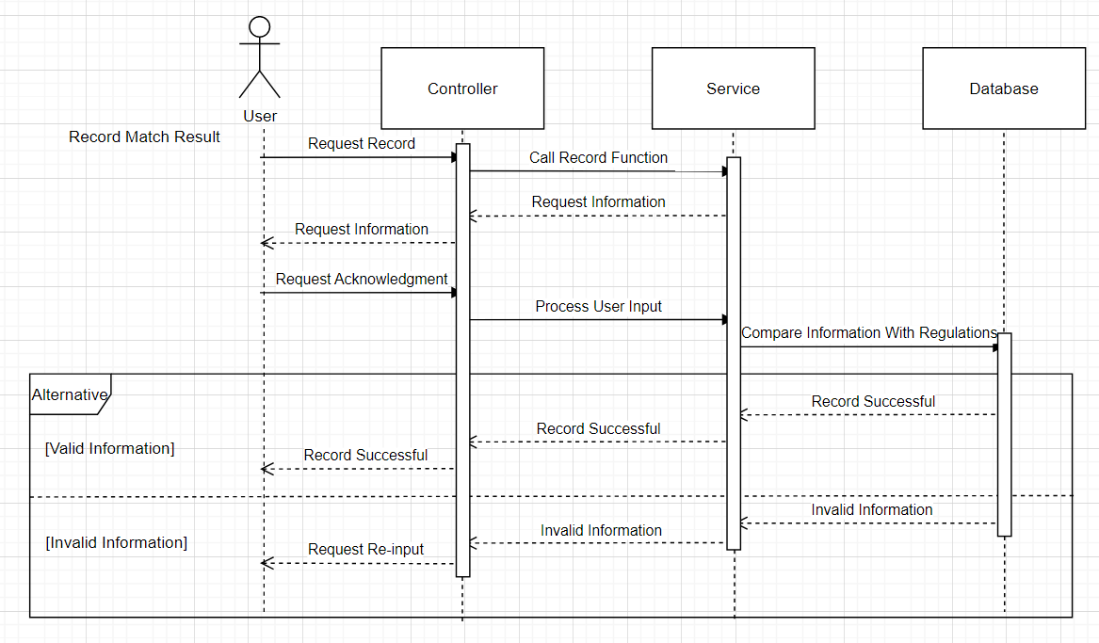

Figure . Record Match Result Sequence Diagram

### 3.5.2. Functional Requirements

## 3.6. Player Lookup

### 3.6.1. Description

Figure . Player Lookup Sequence Diagram

### 3.6.2. Functional Requirements

## 3.7. Create Tournament Report

### 3.7.1. Description

Figure . Create Tournament Report Sequence Diagram

### 3.7.2. Functional Requirements

## 3.8. Change or Add Regulations

### 3.8.1. Description

Figure . Change or Add Regulation Sequence Diagram

### 3.8.2. Functional Requirements

# **4. Data Requirements**

## 4.1. Logical Data Model

Figure . ERD

## 4.2. Data Dictionary

## 4.3. Reports

## 4.4. Data Integrity, Retention, and Disposal

# **5. External Interface Requirements**

## 5.1. User Interfaces

## 5.2. Software Interfaces

## 5.3. Hardware Interfaces

## 5.4. Communications Interfaces

# **6. Quality Attributes**

## 6.1. Usability Requirements

## 6.2. Performance Requirements

## 6.3. Reliability Requirements

## 6.4. Security Requirements

## 6.5. Availabilty Requirements

## 6.6. Inverse Requirements